Minutes of the Annual Meeting of Little Hoole Parish Council Meeting  held on Monday 11th May 2026, at Walmer Bridge Village Hall | 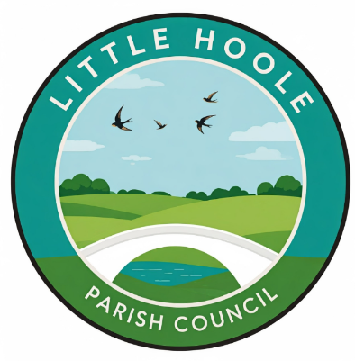

DRAFT Minutes of the Annual Meeting of Little Hoole Parish Council
Held on Monday 11th May 2026, 6:45pm, at Walmer Bridge Village Hall

In attendance:
Cllrs L Dryden (Chair), J Rainsbury, S Rainsbury, T Wilcock, S Evald, D Owen, E Moore.
Mr P Cafferkey (Clerk & Responsible Financial Officer).
No members of the public were present.

- Election of Chair: It was resolved that Cllr Dryden be elected as Chair. Cllr Dryden signed the Declaration of Acceptance of Office.
- Election of Vice Chair: It was resolved that Cllr Owen be elected as Vice Chair.
- Apologies for Absence: None
- Minutes of the Previous Annual Meeting of the Parish Council: It was resolved that the minutes of the previous annual meeting of the Parish Council held on 12th May 2025 be approved.
- Report from Cllr Dryden (as the Chair for 2025/26) on the past year 2025-26: Cllr Dryden gave a brief verbal report on the Parish Council’s achievements during 2025-26. A written version of the Chair’s report is appended to these minutes.
- Public Time: No matters were raised or discussed under this agenda item.
- To resolve to review at future meetings in the coming year: Standing Orders, Financial Regulations, Risk Management Policy, Fixed Asset Register, Insurance Arrangements, Code of Conduct; and any other policies considered necessary.
It was resolved that these policies and procedures, and any other policies considered necessary, would be reviewed during the coming year.
The meeting was immediately followed by the May 2026 Parish Council meeting.

Walmer Bridge, May 2026
Little Hoole Parish Council
(Appendix to the Minutes of the Annual Meeting of Little Hoole Parish Council 11th May 2026)
The Chairmans report for 2025-2026
We have had a quiet and somewhat uneventful year.
A few standout achievements are:
1. We planted for both summer and winter, last year we talked about doing more with bulbs and we planted the Gill Lane roundabout. We obtained the relevant permissions and set 120 bulbs in the autumn. They were a lovely addition to our “Sea of Daffodils” .
I still think we can do more to lift the looks of the village, more flowers and tidier planters.
2. We had summer activities for 4 days in August, there is no doubt that event is well received and better attended every year. We agreed to build on that and do 6 days the year after.
3. We listened to the public and was made aware of several issues regarding speeding, traffic and anti-social behaviour. We took action in form of a public meeting where the police and the parish council was available for questions. It was well attended and we agreed to repeat that type of meeting in the summer half year if needed.
4. We got involved in a few planning and building issues.
After listening to complaints from several residents on Hall Carr Lane, we wrote letters to the planning office to object against a proposed plan. Although we might not have stopped the plans to build a house on the plot in question, we provided support to the resident who needed help with his objections.
We are also involved in a protest over the closure of the pedestrian access to the GP surgery in Longton, this issue is unresolved and we still have work to do on that front.
5. We finally managed to get LCC to repair the underground culvert to solve the reoccurring floods by Old Mill Court and the brook.
It literally took us years to get through to them about this issue, I am happy to report it has been solved, hopefully for a very long time.
6. Our Christmas lights were renewed. Last year’s display was sparse and drab, we invested in new lights and had the 4 trees re dressed. It looked very well compared to the previous year.
I feel we can do more for Christmas and will propose this later this year.
7. We have been involved in the community to help and maintain:
- The Mill Pond is being kept by us.
- We paid for the second half of the school yard markings, this time in the reception area. It looks good and was appreciated.
- We helped the school receive a £200 grant for biodiversity which they used in their ground force project.
- We bought reflective tags for all the school children, 2 different types.
- We provided and installed a Christmas tree for Old Mill Court, it was appreciated.
A few projects were agreed and are only a few weeks away from being finished.
- The tree carving in the park is being done in June
- The Memory bench will have the foundation laid in about a month
- The two remaining bus shelters will be installed this summer.

Thank you to the council for their hard work.
Chairman
Laurence Dryden

